Abby Flexicapture

ABBYY FlexiCapture is the next generation of intelligent, accurate and highly scalable data capture and document processing software.

It provides a single entry point to automatically transform the stream of different forms and documents of any structure and complexity to usable and accessible data ready to be exported into your business applications and databases.

ABBYY FlexiCapture is supremely intelligent, accurate and scalable data capture and document processing system. It provides a single entry point to automatically transform the stream of different forms and documents of any structure and complexity to usable and accessible data ready to be exported into your business applications and databases.

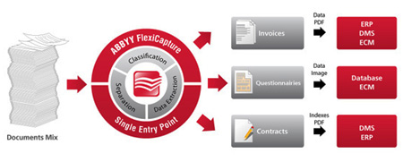

ABBYY FlexiCapture is intended for high-volume automated processing of any kind of documents including

* fixed forms (questionnaires, surveys, tests, tax returns, and application forms);
* semi-structured documents (invoices, purchase orders, explanations of benefits, and receipts);
* unstructured documents (contracts, letters, and articles).

The documents are classified, recognised, verified and transferred into reliable, accurate, searchable and highly structured electronic data critical to business processes.

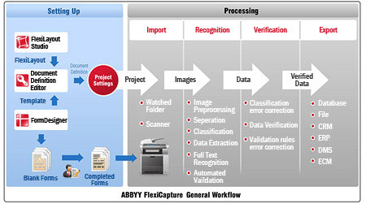

ABBYY FlexiCapture provides powerful set-up tools and flexible processing workflow to accomplish document processing tasks of any complexity.

ABBYY FlexiCapture allows processing documents in batches: prior to processing proper, a batch is created and document images are added into this batch. Batches [are created](https://help.abbyy.com/en-us/flexicapture/12/standalone_administrator/brief_batch) automatically or manually when importing images (i.e. when scanning in documents or when importing the images of already scanned documents). The settings to be used for document processing are specified for each batch type individually. You can create several batch types for the most commonly used sets of processing settings. In this case, all the Operator needs to do is to select the appropriate batch type.

A project can include multiple batch types. Batch types for projects are created in the **Create New Batch Type** dialog box.

To create a new batch type, complete the following steps:

1. Open the project.
2. Click **Batch Types...** on the **Project** menu to open the **Batch Types** dialog box.
3. Click the **New...** button to open the **Create New Batch Type** dialog box and create a new batch type.

The properties dialog box of a batch type contains the following options:

* On the **General** tab you can specify the name of the batch type, provide a description, and specify [the quality of images that will be displayed on processing stations](https://help.abbyy.com/en-us/flexicapture/12/standalone_administrator/image_quality), [registration parameters](https://help.abbyy.com/en-us/flexicapture/12/standalone_administrator/reg_params) and [batch type tools](https://help.abbyy.com/en-us/flexicapture/12/standalone_administrator/batchtype_tools).
* The **Image Processing** tab contains settings that determine how documents are separated, [which preprocessing procedures are applied to images](https://help.abbyy.com/en-us/flexicapture/12/standalone_administrator/image_processing_settings), whether to delete blank pages.
* The **Recognition** tab lets you choose [the order](https://help.abbyy.com/en-us/flexicapture/12/standalone_administrator/batch_types_project_settings#order) in which [Document Definitions](https://help.abbyy.com/en-us/flexicapture/12/standalone_administrator/brief_template) and [document sets](https://help.abbyy.com/en-us/flexicapture/12/standalone_administrator/sets_processing) are applied, which [classifier](https://help.abbyy.com/en-us/flexicapture/12/standalone_administrator/classify_intro) to use, contains recognition settings, and  lets you use NLP to extract named entities.
* The **Event Handlers** tab lets you select which [event handlers](https://help.abbyy.com/en-us/flexicapture/12/standalone_administrator/events) will be used and edit them.
* The **Verification** tab contains an option that groups fields during field verification if enabled.
* The **Export** tab contains settings that determine how documents are [exported](https://help.abbyy.com/en-us/flexicapture/12/standalone_administrator/default_export). If no batch type is specified, batches will be exported using the <**Default**> settings specified in the project's properties.
* On the **Workflow** tab you can set up [workflows](https://help.abbyy.com/en-us/flexicapture/12/standalone_administrator/workflow_project_settings).
* The **.Net References** tab lets you [add external assemblies](https://help.abbyy.com/en-us/flexicapture/12/standalone_administrator/user_assembly).

The **Recognition** tab lets you choose one of the two types of Document Definition matching:

### Use all Document Definitions

### Use selected Document Definitions

To expedite the process of FlexiLayout matching, mark the **Use first acceptable FlexiLayout**option. If it is not marked, the program will try to match all FlexiLayouts and select the best suited one.

https://help.abbyy.com/assets/en-us/flexicapture/12/standalone_administrator/note.gif**Note:**The **Use first acceptable FlexiLayout**option may be also selected in the **Default**batch type.Top of Form

* Name